Cuvier's objection, animal morphogenesis and the evolution of evolvability

Abstract
The french biologist Georges Cuvier was a prominent early opponent of evolution. Cuvier claimed that evolution was impossible because any change to existing body plans would be deleterious. Mathematically Cuvier's objection agrees with the formally proven "No free lunch" theorems for search and learning. What is interesting is why Cuvier was wrong in the case of biological evolution. The paper will use the evolution and morphogenetics of metazoan animals as the example for discussion.
It is shown … / collates evidence that

Mechanism of natural selection driven, adaptive evolution of evolvability based on the effect of known features of the DNA genome.

Keywords: Cuvier's objection, parameterisation, morphogenesis, evolution of evolvability

Introduction
The failure of artificial evolution to reproduce the evolvability and innovation observed in biological evolution, [N. Packard et al., "An Overview of Open-Ended Evolution: Editorial Introduction to the Open-Ended Evolution II Special Issue," in Artificial Life, vol. 25, no. 2, pp. 93-103, May 2019, doi: 10.1162/artl_a_00291. ] suggests that some necessary part of the mechanism of biological evolution has not been understood.

The concept of evolvability has been in use since Thomson (1931: 228, 231) [Thomson, J. A. (1931). Biology and human progress. In W. Rose (Ed.), An outline of human knowledge (pp. 203–252). London, UK: Victor Gollanz Ltd.] [Crother, B.I. and Murray, C.M., 2019. Early usage and meaning of evolvability. Ecology and evolution, 9(7), pp.3784-3793.] and with it the realisation that there is something to be explained. Brown [Brown, R.L., 2014. What evolvability really is. The British Journal for the Philosophy of Science, 65(3), pp.549-572.] examined the use of the term in biology, and defined the concept of evolvability as “an abstract, robust, dispositional property of populations, which captures the joint causal influence of their internal features on the outcomes of evolution”.

Dawkins [ Dawkins, R., 1989. The Evolution of Evolvability Artificial Life, Langton, DG.] recognized the importance of embrological development parameterizing the phenotype space in an efficient way relevant to fitness, and that most parameterizations are highly inefficient. Wagner & Altenberg [Wagner, G.P. and Altenberg, L., 1996. Perspective: complex adaptations and the evolution of evolvability. Evolution, 50(3), pp.967-976.] reviewing evolution in biology and computer science, found “mutation, recombination and selection is not universally effective”, and identified the emergence of modularity as an important factor in evolvability.
There is empirical evidence that evolution of evolvability occurs in biology, which raises the question of whether this occurs adaptively. [Payne, J.L. and Wagner, A., 2019. The causes of evolvability and their evolution. Nature Reviews Genetics, 20(1), pp.24-38.] identified three categories of factors of evolvability (i)“molecular mechanisms that create phenotypic heterogeneity”, (ii) robustness, (iii) “the topographic features of an adaptive landscape”.

[Izquierdo, E. and Fernando, C., 2008. The Evolution of Evolvability in Gene Transcription Networks. In ALIFE (pp. 265-273).] showed in a simple model of gene networks, “that transcription factor binding matrices (TFBM) evolve to positively constrain phenotypic variability in response to transcription factor binding sequence mutations.” [Sundaram, V. and Wysocka, J., 2020. Transposable elements as a potent source of diverse cis-regulatory sequences in mammalian genomes. Philosophical Transactions of the Royal Society B, 375(1795), p.20190347.] identified “transposable elements as a potent source of diverse cis-regulatory sequences in mammalian genomes”, noting that transposable elements compose more than half the human genome.

This theoretical and empirical background informs the hypothesis tendered in this paper, that certain mechanisms of metazoan morphogenesis and DNA mutation play a critical role in the evident evolvability of biological species.

Cuvier’s objection
The supposed ‘impossibility’ of evolution of animal bodies was one of the original objections to evolution in biology. In the “Sacred Ibis debate” of 1802, and “The Great Debate” of 1829 [24 - Curtis et al 2018], Cuvier argued for the fixity of species, asserting “the varieties keep within certain limits fixed by nature” [25 - Cuvier 1825], that any deviation from existing morphology would be detrimental due to loss of critical function. The “fixity” of biological species has been proven wrong by the fossil specimens and discoveries in genetics and morphogenesis that accumulated after Cuvier’s lifetime. However the problems predicted by Cuvier appear to match those encountered in artificial evolution - that the shape of non-trivial fitness functions often limits the range of adaptation achievable by evolutionary methods.

Mutual information
Cuvier’s objection highlights the mutual information between parts that is required to create a working mechanism. This applies whether the information is matching mechanical components (curvature of opposing joint faces, lengths of bones and tendons, muscle contraction and joint excursion), or biochemical systems (e.g. the induction of enzymes required for a pathway).

Distribution of mutations
In biology genetic mutations having some phenotypic effect are common [Acuna-Hidalgo et al 2016]. While some mutations are eliminated by early death in parental germ-line cells or embryos, this does not explain the constrained phenotypic variation observed. Given the observed degree of phenotypic variation, if variation of parts were approximately uniform and independent, a significant proportion of dysfunctional phenotypes would be expected. However the phenotypic variation observed in biological species arising from genetic mutation, is substantially constrained to a range of viable phenotypes. This implies that mutation is somehow constrained to preserve the required mutual information.

The “No free lunch” theorems
Evolutionary algorithms operate within the constraints defined by the “No Free Lunch” theorems for search and learning, [167 – Wolpert & Macready 1995, 168 – Wolpert & Macready 1997, 166 – Wolpert & Macready 2005, 165 – Wolpert 2012] [English, T.M., 1996. Evaluation of Evolutionary and Genetic Optimizers: No Free Lunch. In Evolutionary Programming (pp. 163-169).] . These impose an absolute mathematical constraint, that the better-than-random-search performance of an evolutionary algorithm is specific to a particular problem domain and parameterisation of the domain. This is because
- any evolutionary algorithm contains implied prior information about the distribution of desirable solutions as a function of the genotype and the distribution of mutations,
- for every possible correlation between a given evolutionary algorithm and fitness function, it is mathematically possible to write another fitness function with the opposite correlation, giving correspondingly worse than random search performance.

The “prior” of evolution
The fundamental prior expectation of evolutionary algorithms, is that phenotype fitness correlates with genotype, at least for local subspaces of the genotype. This is required for there to exist gradients in fitness as function of genotype, which cause an evolutionary algorithm to progressively discover genotypes of higher fitness.

For most biological genomes the metaphorical picture is modified by the possibility of neutral mutations that do not by themselves alter phenotype fitness. Consequently evolution may resemble percolation through a network of genotypes, producing intermittent step changes in fitness [63 – Harvey & Thompson 1996)]. This does not alter the requirement for correlation between phenotype fitness and genotype.

Effects of parameterisation
Consider Cuvier’s objection in the context of a naive artificial genome parameterisation for components of a phenotype that must co-vary in order to produce a viable phenotype - for example the curvature of joint faces, parameterised by voxelisation in 3D space. All the viable phenotypes can easily be expressed by this genome, but they are separated from each other in genotype space by many individual voxel changes that are extremely damaging to the function of the phenotype.

Only those genome parameterisations which contain the required information about the dependencies within the set of viable phenotypes, will produce the correlation of genotype with phenotype fitness.

Fully evolvable parameterisations (with no local optima) for a given problem, form a very small subset of the mathematically possible parameterisations. Proportionally, this subset is equal to the reciprocal of the Kolmogorov algorithmic complexity of the required mutual information between parts for viable phenotypes of the species.

Larger sets of parameterisations may exist containing partial information about the constraints. These result in breaking the fitness function into multiple local minima in genotype space.

The most compact subset of highly evolvable parameterisatons describe only viable variations. These present a genotype space orders of magnitude smaller than less evolvable parameterisations. This changes evolutionary improvement of fitness from intractable to highly tractable.

Mechanisms underlying evolution in metazoan animals
In this section lays out a high level view of morphogenetics and genetic mutation, covering only those details required in order to explain (1) the ‘problem’ being solved by biological evolution, (2) how the parameterisation of phenotypes by biological genomes encodes the required prior information about the problem, (3) how this information can be acquired through natural selection.

Search domain of phenotypes
The bodies of animals are diverse in appearance and abilities, but very similar in composition and construction. Large highly mobile animals are all metazoan bilateria, dominated by a few highly adaptable phyla. These phyla define base materials. tissues, and basic body plans that conserve topology and morphogenesis.

Two types of information about phenotype fitness are required,
- co-dependence internal to anatomy and physiology,
- dependence on the external environment – requirements of the niche.

Morphogenesis
Morphogenesis is the interaction of many cells descended from a single zygote, to construct a multicellular organism. Key features of how morphogenesis generates phenotype are
- Branching tree of epigenetic cell lines encoding body part identities,
- Convergence of epigenetic cell lines to a smaller number of tissue generating cell types,
- Parameterization of anatomical topology on local anatomical coordinates produced by morphogen diffusion gradients,
- Sequential growth and refinement, patterning finer details with respect to structures generated in preceding stages,
- Remodelling of tissues on cell environmental information, especially mechanical forces.
The mechanisms underlying these are (in)activation of transcription factor genes, inheritance of epigenetic state by daughter cells, and inter-cellular communication by chemical diffusion of morphogens. These enable the direction of cell behaviours used to define body structures, including clock-and-wavefront, gap-and-pair, cell taxis, adhesion and sorting.

Patterning of topology
The body symmetry of bilateria is formed by breaking the omni-directional symmetry of the blastocoel to establish dorso-ventral and cranio-caudal body axes, by competitive inhibition of morphogen secretion. In chordates the somites and axial body regions are established by the clock-and-wavefront mechanism and Hox gene activation. The limb buds are located with respect to the Hox cell-type, embryonic tissue layers and morphogen gradients. The limb buds in turn generate new internal morphogen gradients which control the definition of the limb segments, and subsequent division into bone primordia, joints, muscles,tendons, and associated nerves and vessels. Epigenetic cell types allow recognition and adhesion to connect required topology, including myotendon junctions, tendon insertions on bones. Equivalent mechanisms exist in other phyla
[Sadler 2018, McGeady et al 2017]

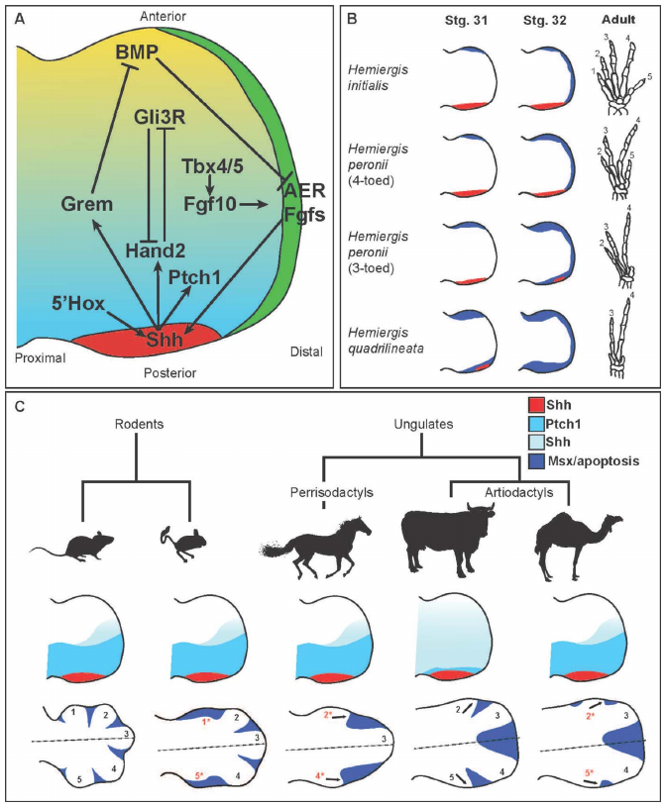 | 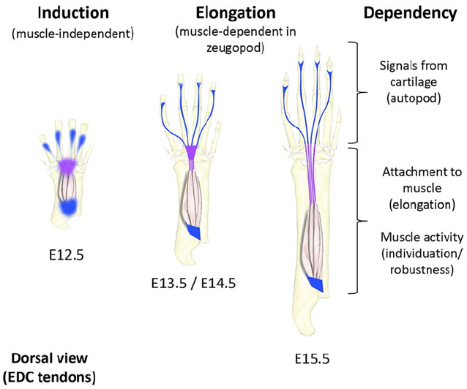
Fig 1 Patterning of topology in morphogenesis.
Left: Morphogen gradients in the mammalian limb bud establish local anatomical coordinates that control morphogenesis. From fig1 of [Young & Tabin, 2017].
Right: Musculoskeletal integration at the mammalian wrist, initial topology formed on morphogen gradients with respect to bone primordia, followed by bone growth and remodelling. From fig 8 of [Huang et al 2015]

Remodelling
The initial geometry formed on morphogen gradients is far simpler than that of the mature foetus. Overall size, proportion and shape are extensively remodelled, while maintaining the original topology. This requires that all body parts grow in coordination with each other, in both size and composition, to arrive at a well integrated body with all parts matching size, shape and material properties. The mechanism is remodelling of tissues both passive and active, on environmental signals including mechanical forces, whole body physiology, and local morphogens. The rules of remodelling are defined by the behaviour of tissue cell types.
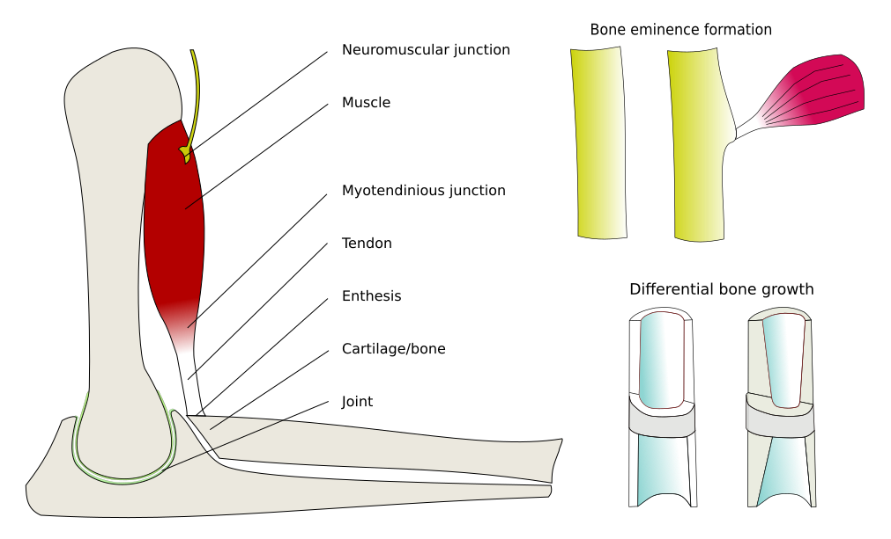
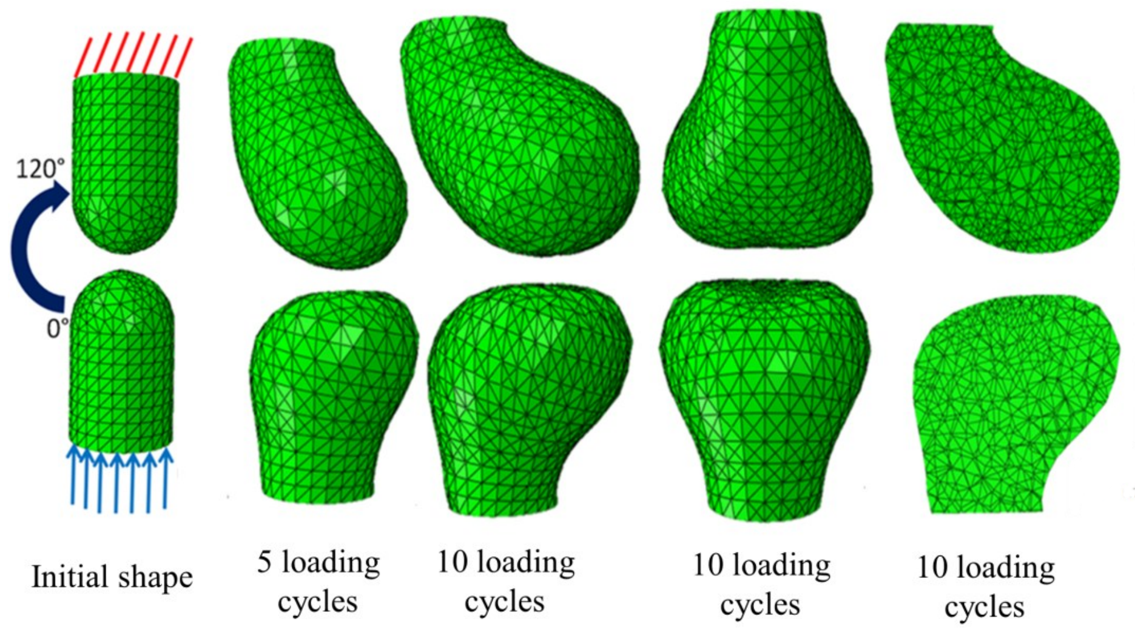
Fig 2. Left: Passive mechanical remodelling of opposing joint faces of bone primordia, joint capsule and menisci not shown. Reproduced with permission from [Giorgi 2015]
Right: Active remodelling of musculoskeletal tissues produces well matched components.
From [Hockings & Howard 2020], drawn from data in [Felsenthal & Zelzer, 2017]

Summary of morphogenesis
• Body structure is formed through the process of morphogenesis as a function of cell behaviour.
• Cell behaviour depends on cell line, diffusion of morphogens, and mechanical forces.
• These allow the co-dependencies of viable phenotypes to be expressed as cell behaviour.

Genotypes and epigenetic regulation
The cell behaviours of morphogenesis are determined by epigenetic regulation, of a single genome common to all the cells of the organism. However cell lines have different regions of the genome permanently silenced, by epigenetic modifications that are inherited by descendant cells.
Protein coding DNA makes only 1-2% of most metazoan genomes. Cis-regulatory DNA elements are sparsely distributed in the non-protein coding DNA associated with each gene cluster.

Key points of genotype and epigenetic regulation
- The genes encode the proteins that form the structure, enzymes, morphogens, and receptors used in the process of morphogenesis.
- Epi-genetic regulation controls which genes are active.
- Gene regulatory networks produce stable cell types.
- Trans-regulatory elements epigenetically encode the current state of a cell.
- Cis-regulatory elements encode the behavioural repertoir of all cell types.

The information that describes a species, and the co-dependencies of viable phenotypes of its niche, is encoded in the cis-regulatory elements of the genome. The set of genes defines the morphogenetic toolkit from which diverse species can evolve. These provide a compact encoding of required information of viable phenotypes. This encoded genetic information is much less than the sequence of base pairs.

Mutation of DNA
The ways in which the DNA mutates, and the distribution of those mutations determine the steps which evolution can take in generating new phenotypes from the existing population. It is essential therefore to know:
- what is present in the DNA sequence
- how it affects mutation of the genome
- the effects of that mutation on phenotype.

Effect of DNA patterns on mutability
Apart from cis-regulatory elements, non-protein coding DNA contains many repeating patterns of various classes [Ronald J Trent 2012, Ch 1 “Genes to Personalized Medicine” In “Molecular Medicine Genomics to Personalized Healthcare”, 4th Edition, 2012 https://doi.org/10.1016/B978-0-12-381451-7.00001-3 ]. Mutational effects of DNA patterns include: (i) increased variability by insertion/deletion errors, (ii) replication slippage and slipped strand mis-pairing, and (iii) increased chance of crossing over [cite…] [Gemayel et al 2010] [Gemayel, R., Vinces, M.D., Legendre, M. and Verstrepen, K.J., 2010. Variable tandem repeats accelerate evolution of coding and regulatory sequences. Annual review of genetics, 44, pp.445-477.
], [Gymrek et al 2016] .

Highly conserved genes are shorter and less likely to be a site of mutation. For example ‘housekeeping’ genes believed to be responsible for essential cell functions, have shorter introns indicating selection for compactness [43 – Eisenberg & Levanon 2003].

Crossing over
Crossing over is the predominant form of recombination mutation observed in animals [cite…], and in vertebrates tends to occur at particular ‘hotspot’ loci determined by PRDM9 binding sites [Paigen & Petkov 2018][Paigen, K. and Petkov, P.M., 2018. PRDM9 and its role in genetic recombination. Trends in Genetics, 34(4), pp.291-300.] determined by patterns in the DNA [cite ...]. In particular, Holliday junctions are most likely to form where the base sequences of the double strands are nearly identical [cite ...], including anywhere sequence repeats occur. The existence of such paralogus sites therefore controls the mutability of regions of the DNA.

Long, H.K., Prescott, S.L. and Wysocka, J., 2016. Ever-changing landscapes: transcriptional enhancers in development and evolution. Cell, 167(5), pp.1170-1187.

Karyotypic mutation
Chromosomes are defined by their telomeres and centromeres can be added or removed by crossing over. Karyoyptic change is very common between closely related species [130 - Scherthan 2001], and between populations of the same species [7 – Arslan & Zima 2014]. There are documented species with variable chromosome numbers within breeding populations, e.g. the ’common house mouse’ [111 – Nachman & Searle 1995].

Genetic effects
Insertion or removal of segments of DNA by crossing over may shuffle, duplicate or insert cis-regulatory or protein coding DNA. Given the small proportion of protein coding DNA, mutations are much more likely to affect non-coding DNA and therefore cis-regulatory elements. Crucially crossing over may also add or remove hotspot loci, and therefore alter the probability of future mutations in that region of the genome.

The division of the genome into chromosomes affects (i) the possible and probable changes of gene regulation and gene duplication that crossing over can cause in a species, (ii) which genes may assort independently, and (iii) whether two populations can interbreed to produce fertile offspring, or are genetically isolated.

Phenotypic effects
The distribution and effect of mutations determines the distribution of sampling of new phenotypes. Mutations, in rough order of frequency, may have the following effects on morphogenesis:

- Tuning regulation of existing gene networks - may incrementally affect the position, thickness or composition of a tissue layer.
- Creating new links in gene networks - by insertion of regulatory elements receptive to trans-regulatory factors from different regulatory genes - may change where a tissue type is produced, or what stimuli remodelling is sensitive to.
- Changing the architecture of the genome - as discussed in section 5.3.6, this alters the probabilities of future mutations and therefore the subspace of the genome accessible to evolution.
- Changing the number of repeated parts in the body - e.g. number of ripples in a morphogenetic field.
- Creating new structure in the body - a new cluster of genes providing distinct regulation of morphogenesis of tissue layers and topology.

Summary of mutation of DNA
- The genome does not mutate uniformly with respect to genes.
- DNA patterns influence where mutations occur.
- Most mutation occurs in the regulation of genes, not the protein-coding exons.
- Chromosome architecture determines the probability and possibility of mutations, and therefore which subspace of the genome is accessible to evolution.
- In this way evolvability is implicitly encoded in the genome, and therefore itself accessible to evolution.

This completes the chain of problem domain, parameterisation, and sampling distribution required to define an evolutionary algorithm. In the multicellular biological version we have an additional intermediate link in the form of morphogenesis by cell behaviour. This facilitates access to the additional environmental information needed to correctly describe the co-dependencies in the phenotype. The final encoding in the DNA provides a doubly abstracted domain specific language for the efficient expression of the required information of viable phenotypes in evolvable form.

Expected evolutionary effects
This section discusses the theoretically expected evolutionary effects of the features highlighted in the previous sections.

Body plan
Much of the domain knowledge of how to build bodies lies in the regulatory architecture of the basic body plan. Given the body plan, the diverse adaptations of animals are produced primarily by adjusting geometric and compositional proportions. From the No Free Lunch algorithms (section 2.3) these body plans can only be adapted to particular niches, about which they contain implied information. Little overlap is seen in the niches of animals of fundamentally different body plans. Due to the non-computability of Komolgorov complexity, it is also impossible to prove the non-existence of other highly adaptable body plans, of potential phyla.

Selection for an axis of evolvability, low mutability
Most possible mutations of the genome that have genetic effect, produce only malformation, loss of multicellular organisation, or cell death. This is because they lose necessary mutual information for the maintenance of viable anatomy, physiology and identity of a multicellular organism, or even of a living cell, e.g. mutual information between cell homeostatic processes, cell types, tissues, organs and the body as a whole. Such mutations are seen under the influence of external mutagens such as ionising radiation, but much more rarely in normal environmental conditions.

Evolution tends to minimise the likelihood of such dysfunctional mutations arising. Such mutability is a deleterious trait that is heavily selected against by differential survival of offspring over successive generations. Alleles that increase such risks are minimised in the gene pool. This particularly affects DNA encoded gene-specific mutability, such as DNA patterns.

This ominpresent kin-selection for mutationally-safe genotypes restricts evolution to an evolvable subspace of expressible genotypes. in which only certain genes are likely to mutate. Evolvability of the genome as a whole does not necesitate the evolvability of each gene. There are three alternate outcomes of selection on mutations that alter the evolvability of a gene:
- Alleles that provide a high rate of safe mutation and some improvement on fitness, are selected for. Such genes by implication must encode any required mutual information between the phenotypic traits they influence. This promotes the accumulation of such information in the genotype.
- If the new allele of the gene has a high probability of mutation producing non-viable offspring, then the allele is likely to be eliminated from the population.
- If the new allele has low mutability, such that further mutations leading to non-viable offspring are as rare as for other allele’s of the gene, then if the new allele improves fitness it may increase in frequency in the population.

Note that this process is distinct from the concept of ‘purifying selection’, in that it minimises mutation of critical genes so preventing the emergence of new alleles, rather than exercising selection on them. This reduction in mutational diversity closes off some potential avenues of evolution, but increases the potential rate of evolution, by concentrating mutations within a subspace where nearly all offspring have viable phenotypes.

An apparent example
An apparent example of these alternate routes of evolution is the notochord of chordates.

(a) In the urochordate sub-phylum the notochord is primarily a mechanical structure, and the body pattern is relatively simple. Within the urochordates, class thaliacea have lost their notochord [72 – Holland 2016]. Here the low mutual information associated with the notochord allowed mutation, (1) above.

(b) In contrast in the vertebrate sub-phylum, signals from the notochord are used in many body patterning processes, critical to the fitnesss of the phenotype. The number of dependent processes mean that mutations which conserve the mutual information, necessary for viable body patterns, are a small subset of possible mutations. In vertebrates not only the phenotypic form of the notochord but also the sequence of the genes regulating it, are highly conserved, [109 – Muller & Wagner 1991],[100 – Maguire et al 2018]. The rarity of exon shuffling in highly conserved genes indicates low mutability, rather than mutability under purifying selection, [22 – Conant & Wagner 2005].

Here first mutual information about viable vertebrate bodies was accumulated in genes dependent on the notochord, (1) above. This lead to a high probability that mutations to the genes specifying notochord itself would be non-viable, (2) above. Therefore mutations that reduced mutability of the notochord were favoured, (3) above.

Evidence for gene specific evolution of evolvability
There is (i) an observed 100 fold variation in conservation of vertebrate genes, [98 – Lupski 2007],[106 – Michaelson et al 2012], (ii) the presence of molecular mechanisms and DNA patterns (section 5.3.1, appendix B.1) controlling mutability, [136 – Shendure & Akey 2015] and (iii) the existence of strong selective pressure.

Together these indicate an important role for gene specific genetic control of mutability in the evolution of evolvability.

Types of innovation and information

Micro-evolution
The establishment of a genome with the distribution of mutations skewed to safe variations that produce viable phenotypes allows rapid micro-evolution within established body plans. This is seen in selective breeding of domestic species, and the rapid evolution of isolated populations of wild species [cite ….]. Conversely selection on existing variable traits can produce rapid evolution and speciation. Lizards on newly isolated islands showed head ….
This may include speciation and radiation into available niches.

While good morphogenetic parameterization can encode established information about mutual dependencies of viable phenotypes, and so facilitate micro-evolution, it cannot encode what has not yet been discovered. This fundamentally separates micro-evolution from true innovation and macro-evolution.

Macro-evolution
Fundamental innovation involves capturing information about new body plans, as opposed to adjusting the parameters of an existing model. By this proposed definition, macro-evolution would be defined in retrospect, as the acquisition of information about viable phenotypes that enables a new radiation of species. This may involve:

- New body morphogenetic mechanisms, including new connections in gene regulatory networks and new body-part genetic identities,
- New phenotypic structures – e.g. feathers from scales, limbs from fins.
- New relations of existing structures to the niche – e.g. tetrapod fish hands for terrestrial locomotion, feathered therapod forelimbs as wings, canine teeth as tusks.

Corollary to Cuvier’s objection, there needs to be selective pressure for each step on the way to discovering information about new phenotype-environment relationships. The intermediate species leading to major innovations may be highly specialized, gaining partial access to the potential benefits of the innovation. The need for changing selection pressures suggests environmental evolution of niches as an important driver of innovation.

Why morphogenetic innovation is rare
A major body plan innovation and intermediate forms leading to it, are defined in retrospect, on the basis of adaptive radiation that followed. Adaptive radiation indicates the ‘discovery’ of a highly evolvable body plan.

Consider the prior probabilities of the following subsets of mutations.
- Mutationally accessible morphogenetic changes capable of expressing a particular codependence in morphology.
- Changes of morphogenetic co-dependence capable of improving fitness.
- The subset of (2) that may be useful steps towards a set of innovations sufficient to make a large group of related niches accessible.
- The subset of (2) that reduce the likelihood of (3), i.e. dead end specialisations.

Increased fitness alone is not sufficient for a mutation to survive and increase within a gene pool.
- If further mutations have a distribution that produces heightened mortality, then the new morphology is not evolvable,.
- If recombination of the new genotype with the existing gene pool tends to produce non-viable or unfit offspring, then the new genotype is deleterious, and will be selected against.

Morphogenetic location of major innovations
Innovation is most likely to occur in non-essential parts of the gene regulatory network of the body plan, where natural selection does not drive reduction of mutability. For example the pygostele (spelling ? ) holding the tail feathers of birds, first appears as a tail tip appendage in therapods. possibly used for display [cite...].

exaptation requires serendipidous coincidence of mutual information between the constraints of previous and future functions.

Conclusions
Cuvier’s objection is a fundamental problem in evolution, closely related to the No Free Lunch theorems. Naive or arbitrary parameterizations are likely to have low evolvability, no better than random search, potentially much worse. Evolvability at the level of micro-evolution requires a genotype parameterization, which contains the required mutual information between the components of viable phemotypes. Such parameterization is intrinsically domain specific.

• Metazoan morphogenesis creates a domain specific language, advantageous for expressing the mutual information in animal bodies in evolvable form.
• Kin selection for mutationally safe genotypes, restricts drives evolution of gene-specific mutability controlled by DNA patterns. This confines biological evolution to evolvable genotypes, which express the required mutual information between body parts of viable phenotypes.
• Evolution and radiation of species is substantially dependent on evolution of niches due to external environmental changes.
• True innovation is fundamentally different from micro-evolution, because it requires the capture of new information about mutual dependencies in viable phenotypes.
• Innovation is unpredictable and many orders of magnitude slower than micro-evolution, because the search space is not well constrained.
• Major transitions in evolution depend on multiple previous innovations being co-optable to a newly accessible class of niches. This requires the coincidence of mutual information between the constraints of previous and future functions.

The language of morphogenesis shows that optimal parameterization of biological structures is less complex than first impressions might suggest. We have shown that (i)sequential development, (ii)relative timing, (iii)local coordinates and especially (iv)remodelling in response to physical forces are key components of how biological morphogenesis produces viable bodies. Sequential development allows successive scales of detail to be developed, while morphogenetic marking of cells by homeobox genes facilitates body-part differentiation and repetition with variation, (as previously demonstrated by [38 – Doursat & Sánchez 2014]).

Basic body plans of animals are adapted to diverse niches by relatively few variables specifying geometric and compositional proportions. These body plans amount to technologies for building a bodies for a large range of niches, but the range of niches covered by each clade is mostly non-overlapping.

# NB anticipate equivalent encodings (I) in other multicellular kingdoms – plants, fungi, slime molds…
(II) also for single cell mutual information of both eukaryotes and prokaryotes.
(III) DNA patterns and kin selection provide a mechanism that is likely to be present in each of these cases, and may be common to D/RNA based life.
Provides a purely passive chemical mechanism whereby entropy causes evolvability to emerge.
Caveats – (1) need not be the only nor the predominant mechanism (2) certain to be far more biochemical detail in each biological specie.

References

[N. Packard et al., "An Overview of Open-Ended Evolution: Editorial Introduction to the Open-Ended Evolution II Special Issue," in Artificial Life, vol. 25, no. 2, pp. 93-103, May 2019, doi: 10.1162/artl_a_00291. ]

[Thomson, J. A. (1931). Biology and human progress. In W. Rose (Ed.), An outline of human knowledge (pp. 203–252). London, UK: Victor Gollanz Ltd.]

[Crother, B.I. and Murray, C.M., 2019. Early usage and meaning of evolvability. Ecology and evolution, 9(7), pp.3784-3793.]

[Brown, R.L., 2014. What evolvability really is. The British Journal for the Philosophy of Science, 65(3), pp.549-572.]

[Dawkins, R., 1989. The Evolution of Evolvability Artificial Life, Langton, DG.]

[Wagner, G.P. and Altenberg, L., 1996. Perspective: complex adaptations and the evolution of evolvability. Evolution, 50(3), pp.967-976.]

[Payne, J.L. and Wagner, A., 2019. The causes of evolvability and their evolution. Nature Reviews Genetics, 20(1), pp.24-38.]

[Izquierdo, E. and Fernando, C., 2008. The Evolution of Evolvability in Gene Transcription Networks. In ALIFE (pp. 265-273).]

[Sundaram, V. and Wysocka, J., 2020. Transposable elements as a potent source of diverse cis-regulatory sequences in mammalian genomes. Philosophical Transactions of the Royal Society B, 375(1795), p.20190347.]

====

[24],Curtis, C., Millar, C. D., and Lambert, D. M. (2018). The sacred ibis debate: The first test of evolution. PLoS biology, 16(9):e2005558.

[25] Cuvier, B. G. (1825). Discourse on the revolutionary upheavals on the surface of the globe and on the changes which they have produced in the animal kingdom. Trans. I. Johnson. www. mala. bc. ca/% 7Ejohnstoi/cuvier-e. htm, pages 42,49.

[Acuna-Hidalgo et al 2016] [cite…] Acuna-Hidalgo, R., Veltman, J.A. and Hoischen, A., 2016. New insights into the generation and role of de novo mutations in health and disease. Genome biology, 17(1), p.241.

[167, Wolpert, D. H., Macready, W. G., et al. (1995). No free lunch theorems for search. Technical report, Technical Report SFI-TR-95-02-010, Santa Fe Institute

168, Wolpert, D. H., Macready, W. G., et al. (1997). No free lunch theorems for optimization. IEEE transactions on evolutionary computation, 1(1):67–82.

166, Wolpert, D. H. and Macready, W. G. (2005). Coevolutionary free lunches. IEEE Transactions on Evolutionary Computation, 9(6):721–735.

165] Wolpert, D. H. (2012). What the no free lunch theorems really mean; how to improve search algorithms. In Santa Fe Institute, volume 4.

[English, T.M., 1996. Evaluation of Evolutionary and Genetic Optimizers: No Free Lunch. In Evolutionary Programming (pp. 163-169).]

[63].Harvey, I. and Thompson, A. (1996). Through the labyrinth evolution finds a way: A silicon ridge. In International Conference on Evolvable Systems, pages 406–422. Springer.

[128, Sadler, T. W. (2018). Langman’s Medical Embryology, 14e. Lippincott, Williams & Wilkins.

103] McGeady, T. A., Quinn, P. J., FitzPatrick, E., Ryan, M., Kilroy, D., and Lonergan, P. (2017). Veterinary embryology. John Wiley & Sons.

[Young & Tabin, 2017]. [cite “Saunders framework for limb development] Young, J.J. and Tabin, C.J., 2017. Saunders's framework for understanding limb development as a platform for investigating limb evolution. Developmental biology, 429(2), pp.401-408.

[Huang et al 2015] [cite “Musculoskeletal integration at the wrist”] Huang, A.H., Riordan, T.J., Pryce, B., Weibel, J.L., Watson, S.S., Long, F., Lefebvre, V., Harfe, B.D., Stadler, H.S., Akiyama, H. and Tufa, S.F., 2015. Musculoskeletal integration at the wrist underlies the modular development of limb tendons. Development, 142(14), pp.2431-2441.

Giorgi, M., 2015. Mechanobiological predictions of fetal joint morphogenesis (Doctoral dissertation, Imperial College London).

(Hockings & Howard 2020) Hockings, N. and Howard, D., 2020. New biological morphogenetic methods for evolutionary design of robot bodies. Frontiers in Bioengineering and Biotechnology, 8, p.621. doi: 10.3389/fbioe.2020.00621

(Felsenthal and Zelzer, 2017) Felsenthal, N. and Zelzer, E., 2017. Mechanical regulation of musculoskeletal system development. Development, 144(23), pp.4271-4283.

[cite….] [Ronald J Trent 2012, Ch 1 “Genes to Personalized Medicine” In “Molecular Medicine Genomics to Personalized Healthcare”, 4th Edition, 2012 https://doi.org/10.1016/B978-0-12-381451-7.00001-3 ]

[cite…] [Gemayel et al 2010] [Gemayel, R., Vinces, M.D., Legendre, M. and Verstrepen, K.J., 2010. Variable tandem repeats accelerate evolution of coding and regulatory sequences. Annual review of genetics, 44, pp.445-477.]

[Gymrek et al 2016] Gymrek, M., Willems, T., Guilmatre, A., Zeng, H., Markus, B., Georgiev, S., Daly, M.J., Price, A.L., Pritchard, J.K., Sharp, A.J. and Erlich, Y., 2016. Abundant contribution of short tandem repeats to gene expression variation in humans. Nature genetics, 48(1), p.22.

[43] Eisenberg, E. and Levanon, E. Y. (2003). Human housekeeping genes are compact. TRENDS in Genetics, 19(7):362–365.

[cite…]

[Paigen & Petkov 2018] [cite ...][Paigen, K. and Petkov, P.M., 2018. PRDM9 and its role in genetic recombination. Trends in Genetics, 34(4), pp.291-300.]

[cite ...]

[130] Scherthan, H. (2001). Chromosome numbers in mammals. e LS. https://doi.org/10.1002/9780470015902.a0005799.pub3

[7] Arslan, A. and Zima, J. (2014). Karyotypes of the mammals of turkey and neighbouring regions: a review. Folia zoologica, 63(1):1–63.

[111] Nachman, M. W. and Searle, J. B. (1995). Why is the house mouse karyotype so variable? Trends in ecology & evolution, 10(10):397–402.

[72] Holland, L. Z. (2016). Tunicates. Current Biology, 26(4):R146–R152. https://doi.org/10.1016/j.cub.2015.12.024

[109] Muller, G. B. and Wagner, G. P. (1991). Novelty in evolution: restructuring the concept. Annual review of ecology and systematics, 22(1):229–256.

[100] Maguire, J. E., Pandey, A., Wu, Y., and Di Gregorio, A. (2018). Investigating evolutionarily conserved molecular mechanisms controlling gene expression in the notochord. In Transgenic Ascidians, pages 81–99. Springer.

[22] Conant, G. C. and Wagner, A. (2005). The rarity of gene shuffling in conserved genes. Genome biology, 6(6):R50.

[98] Lupski, J. R. (2007). Genomic rearrangements and sporadic disease. Nature genetics, 39(7s):S43

[106] Michaelson, J. J., Shi, Y., Gujral, M., Zheng, H., Malhotra, D., Jin, X., Jian, M., Liu, G., Greer, D., Bhandari, A., et al. (2012). Whole-genome sequencing in autism identifies hot spots for de novo germline mutation. Cell, 151(7):1431–1442.

[136] Shendure, J. and Akey, J. M. (2015). The origins, determinants, and consequences of human mutations. Science, 349(6255):1478–1483.

[cite ….]

[cite...].

[38] Doursat, R. and Sánchez, C. (2014). Growing fine-grained multicellular robots. Soft Robotics, 1(2):110–121.

